Maumee River Bridge: Preliminary Engineering Report

TABLE OF CONTENTS

C.1 Description of Project Components 2
C.2 Verification of Project Components 6
C.3 Schematic Drawings 6
Detailed Project Location Map 6
Schematic Plan Drawing 7
Aerial with Project Components 7
C.4 Feasibility Study 8
C.5 Proposed Method of Construction 8
C.6 Construction Contracts 8
C.7 Detailed Cost Estimate 8
C.8 Real Property Acquisition 8
C.9 List of Permits 8
C.10 Overall Estimated Project Schedule 10
C.11 Overall Project Budget Breakdown 10

C.1 DESCRIPTION OF PROJECT COMPONENTS

The proposed project will consist of the construction of a new bridge to connect two industrial areas located north and south of the Maumee River in Henry County, Ohio. The proposed bridge will be multi-span with a total span of approximately 1,125 feet. The project also includes 625 feet of roadway to be installed and two roundabouts to be constructed at either end of the project termini. The total construction cost of the proposed bridge totals $13,593,223. The project components and quantities are as shown in the following table:

  - Table 1: Project Components and Quantities
DESCRIPTION | UNIT | QUANTITY
CLEARING AND GRUBBING | LS | 1.000
PAVEMENT REMOVED | SY | 76.000
PAVEMENT REMOVED, ASPHALT | SY | 8,563.000
GUARDRAIL REMOVED | FT | 1,207.000
BUILDING DEMOLISHED: 16'x12' SHED WITH FOUNDATION | LS | 1.000
REMOVAL MISC.: FLOWER BED REMOVED | SF | 180.000
EXCAVATION | CY | 10,617.000
EXCAVATION, AS PER PLAN | CY | 16,879.000
EMBANKMENT | CY | 64,482.000
SPECIAL - SETTLEMENT PLATFORM | EACH | 4.000
GUARDRAIL, TYPE MGS | FT | 87.500
GUARDRAIL, TYPE MGS WITH LONG POSTS | FT | 1,700.000
ANCHOR ASSEMBLY, TYPE E | EACH | 2.000
ANCHOR ASSEMBLY, TYPE T | EACH | 1.000
BRIDGE TERMINAL ASSEMBLY, TYPE 1 | EACH | 2.000
BRIDGE TERMINAL ASSEMBLY, TYPE 2 | EACH | 2.000
4" CONCRETE WALK | SF | 2,852.000
CURB RAMP | SF | 1,118.000
MONUMENT ASSEMBLY | EACH | 7.000
MONUMENT BOX ADJUSTED TO GRADE | EACH | 1.000
REFERENCE MONUMENT | EACH | 1.000
FIRE HYDRANT ADJUSTED TO GRADE | EACH | 1.000
VALVE BOX ADJUSTED TO GRADE | EACH | 2.000
SPECIAL - MAILBOX SUPPORT | EACH | 2.000
SPECIAL - MAILBOX REMOVED AND RESET | EACH | 3.000
TIED CONCRETE BLOCK MAT, TYPE 2 | SY | 88.000
ROCK CHANNEL PROTECTION, TYPE C WITH FILTER | CY | 14.000
TOPSOIL | CY | 3,156.000
SEEDING AND MULCHING | SY | 28,428.000
REPAIR SEEDING AND MULCHING | SY | 1,421.000
INTER-SEEDING | SY | 1,421.000
COMMERCIAL FERTILIZER | TON | 3.960
LIME | ACRE | 5.880
DESCRIPTION | UNIT | QUANTITY
WATER | MGAL | 158.000
MOWING | MSF | 64.000
DITCH EROSION PROTECTION | SY | 1,506.000
STORM WATER POLLUTION PREVENTION PLAN | LS | 1.000
EROSION CONTROL | EACH | 110,000.000
PIPE REMOVED | FT | 232.000
CATCH BASIN REMOVED | EACH | 2.000
CONCRETE MASONRY | CY | 2.000
6" SHALLOW PIPE UNDERDRAINS | FT | 5,873.000
6" CONDUIT, TYPE B | FT | 201.000
6" CONDUIT, TYPE E | FT | 100.000
6" CONDUIT, TYPE F | FT | 455.000
12" CONDUIT, TYPE B | FT | 664.000
12" CONDUIT, TYPE C | FT | 676.000
12" CONDUIT, TYPE D | FT | 20.000
12" CONDUIT, TYPE F | FT | 94.000
15" CONDUIT, TYPE C | FT | 149.000
18" CONDUIT, TYPE B | FT | 63.000
18" CONDUIT, TYPE C | FT | 141.000
24" CONDUIT, TYPE C | FT | 155.000
CATCH BASIN, NO. 3 | EACH | 6.000
CATCH BASIN, NO. 3A | EACH | 12.000
CATCH BASIN, NO. 2-2B | EACH | 5.000
CATCH BASIN, NO. 2-3 | EACH | 1.000
MANHOLE ADJUSTED TO GRADE | EACH | 3.000
PRECAST REINFORCED CONCRETE OUTLET | EACH | 3.000
SUBGRADE COMPACTION | SY | 10,733.000
EXCAVATION OF SUBGRADE | CY | 4,226.000
GRANULAR MATERIAL, TYPE B | CY | 4,226.000
PROOF ROLLING | HOUR | 4.000
PAVEMENT PLANING, ASPHALT CONCRETE | SY | 590.000
ASPHALT CONCRETE BASE, PG64-22 | CY | 2,037.000
AGGREGATE BASE | CY | 3,254.000
TACK COAT | GAL | 1,544.000
SEALING, MISC.: LONGITUDINAL JOINT SEALER | LB | 2,498.000
ASPHALT CONCRETE SURFACE COURSE, TYPE 1, (446), AS PER PLAN | CY | 442.000
ASPHALT CONCRETE INTERMEDIATE COURSE, TYPE 2, (446), AS PER PLAN | CY | 618.000
ASPHALT CONCRETE INTERMEDIATE COURSE, TYPE 1, (448) (WEDGING) | CY | 13.000
6" NON-REINFORCED CONCRETE PAVEMENT, CLASS QC1 | SY | 44.000
NON-REINFORCED CONCRETE PAVEMENT, MISC.: DECORATIVE, TRUCK APRON | SY | 754.000
AGGREGATE WALK: 1" LIMESTONE SCREENINGS | SF | 4,178.000
WALKWAY, MISC.: DECORATIVE CONCRETE, 6" SPLITTER ISLAND | SF | 13,284.000
COMBINATION CURB AND GUTTER, TYPE 2 | FT | 3,607.000
COMBINATION CURB AND GUTTER, TYPE 2, AS PER PLAN | FT | 32.000
CURB, TYPE 2-A | FT | 376.000
COMBINATION CURB AND GUTTER, TYPE 3, AS PER PLAN | FT | 590.000
CURB, TYPE 4-C | FT | 52.000
CURB, TYPE 6 | FT | 2,690.000
CONNECTION, FUSED PULL APART | EACH | 28.000
CONNECTION, UNFUSED PERMANENT | EACH | 8.000
LIGHT POLE, CONVENTIONAL AT08B30 | EACH | 6.000
LIGHT POLE, CONVENTIONAL AT14B30 | EACH | 8.000
LIGHT POLE FOUNDATION, 24" X 6' DEEP | EACH | 14.000
NO. 8 AWG 600 VOLT DISTRIBUTION CABLE | FT | 6,652.000
NO. 10 AWG POLE AND BRACKET CABLE | FT | 1,160.000
CONDUIT, 1-1/2", 725.04 | FT | 1,423.000
CONDUIT, 3", 725.04 | FT | 311.000
LUMINAIRE, CONVENTIONAL 150 W, TYPE II DISTRIBUTION | EACH | 8.000
LUMINAIRE, CONVENTIONAL 250 W, TYPE II DISTRIBUTION | EACH | 6.000
TRENCH, 24" DEEP | FT | 1,423.000
PULL BOX, 725.08, 18" | EACH | 10.000
GROUND ROD | EACH | 14.000
POWER SERVICE, AS PER PLAN | EACH | 2.000
PLASTIC CAUTION TAPE | FT | 1,423.000
DELINEATOR, POST SURFACE MOUNTED | EACH | 7.000
RPM | EACH | 17.000
BARRIER REFLECTOR | EACH | 59.000
GROUND MOUNTED SUPPORT, NO. 3 POST, AS PER PLAN | FT | 836.500
SIGN POST REFLECTOR | EACH | 22.000
SIGN, FLAT SHEET | SF | 365.300
SIGN ERECTED, FLAT SHEET | SF | 365.300
REMOVAL OF GROUND MOUNTED SIGN AND DISPOSAL | EACH | 1.000
REMOVAL OF GROUND MOUNTED SIGN AND REERECTION | EACH | 2.000
REMOVAL OF GROUND MOUNTED POST SUPPORT AND DISPOSAL | EACH | 10.000
REMOVAL OF POLE MOUNTED SIGN AND DISPOSAL | EACH | 7.000
SIGNING, MISC.: REMOVAL OF SOLID WOOD POST | EACH | 1.000
SIGNING, MISC.: 4"x6" SOLID WOOD POST | FT | 15.200
EDGE LINE, 4" | MILE | 1.610
CENTER LINE | MILE | 0.770
CROSSWALK LINE, AS PER PLAN | FT | 260.000
TRANSVERSE/DIAGONAL LINE | FT | 144.000
RAILROAD SYMBOL MARKING | EACH | 1.000
LANE ARROW | EACH | 8.000
DOTTED LINE, 12" | FT | 306.000
YIELD LINE | FT | 113.000
MULCH | CY | 74.000
GROUNDCOVER AND VINES, 1 YEAR, POTTED SCHIZACHYRIUM SCOPARIUM - 'LITTILE BLUESTEM' | EACH | 176.000
EVERGREEN SHRUB, 12" HEIGHT JUNIPERUS HORIZONTALIS - 'ANDORRA YOUNGSTOWN' | EACH | 64.000
LANDSCAPE WATERING | GAL | 1,400.000
EVERGREEN TREE, 8' HEIGHT TAXODIUM DISTICHUM - 'BALDCYPRESS' | EACH | 6.000
DESCRIPTION | UNIT | QUANTITY
COFFERDAMS AND EXCAVATION BRACING | LS | 1.000
UNCLASSIFIED EXCAVATION, AS PER PLAN | LS | 1.000
PILE DRIVING EQUIPMENT MOBILIZATION | LS | 1.000
STEEL PILES HP12X53, FURNISHED | FT | 1,630.000
STEEL PILES HP12X53, DRIVEN | FT | 1,360.000
EPOXY COATED REINFORCING STEEL, AS PER PLAN | LB | 606,696.000
CLASS QC2 CONCRETE WITH QC/QA, BRIDGE DECK, AS PER PLAN | CY | 1,060.000
CLASS QC2 CONCRETE WITH QC/QA, SUPERSTRUCTURE | CY | 93.000
CLASS QC2 CONCRETE WITH QC/QA, BRIDGE DECK (PARAPET) | CY | 152.000
CLASS QC1 CONCRETE WITH QC/QA, PIER ABOVE FOOTINGS, AS PER PLAN | CY | 499.000
CLASS QC1 CONCRETE WITH QC/QA, ABUTMENT INCLUDING FOOTING | CY | 409.000
CLASS QC2 CONCRETE WITH QC/QA, SIDEWALK | CY | 205.000
SEALING OF CONCRETE SURFACES (EPOXY-URETHANE) | SY | 5,528.000
TYPE 2 WATERPROOFING | SY | 1.000
STRUCTURAL STEEL MEMBERS, LEVEL UF, AS PER PLAN | LB | 9,389.000
DRAPED STRAND PRESTRESSED CONCRETE BRIDGE I-BEAM MEMBERS, LE VEL 3, TYPE WF72-49 | EACH | 32.000
INTERMEDIATE DIAPHRAGMS, AS PER PLAN | EACH | 72.000
SPECIAL - MODULAR EXPANSION JOINT | FT | 78.000
1" PREFORMED EXPANSION JOINT FILLER | SF | 115.000
1-1/2" PREFORMED EXPANSION JOINT FILLER | SF | 126.000
ELASTOMERIC BEARING WITH INTERNAL LAMINATES AND LOAD PLATE (NEOPRENE) 15"x41"x2" | EACH | 52.000
ELASTOMERIC BEARING WITH INTERNAL LAMINATES AND LOAD PLATE (NEOPRENE) 15"x41"x2.1875" | EACH | 4.000
ELASTOMERIC BEARING WITH INTERNAL LAMINATES AND LOAD PLATE (NEOPRENE) 15.5"x41"x2" | EACH | 8.000
RAILING (CONCRETE PARAPET WITH TWIN STEEL TUBE RAILING) | FT | 1,008.000
SCUPPERS, INCLUDING SUPPORTS, AS PER PLAN | EACH | 8.000
POROUS BACKFILL WITH GEOTEXTILE FABRIC | CY | 189.000
6" PERFORATED CORRUGATED PLASTIC PIPE | FT | 137.000
6" NON-PERFORATED CORRUGATED PLASTIC PIPE, INCLUDING SPECIAL S | FT | 56.000
6" PIPE DOWNSPOUT, INCLUDING SPECIALS | FT | 25.000
DRILLED SHAFTS, 66" DIAMETER, INTO BEDROCK, AS PER PLAN | FT | 231.000
DRILLED SHAFTS, 72" DIAMETER, ABOVE BEDROCK, AS PER PLAN | FT | 104.000
DRILLED SHAFTS, MISC.: DRILLED SHAFT OSTERBERG LOAD TEST, AS PER PLAN | EACH | 1.000
REINFORCED CONCRETE APPROACH SLABS (T=17"), AS PER PLAN | SY | 265.000
TYPE A INSTALLATION | FT | 81.000
ROCK CHANNEL PROTECTION, TYPE C WITH AGGREGATE FILTER | CY | 615.000
12" CONDUIT, TYPE C 707.45 | FT | 784.000
POLYMER MODIFIED ASPHALT EXPANSION JOINT SYSTEM | CF | 81.000
TRAFFIC COMPACTED SURFACE, TYPE A OR B | CY | 100.000
WORK ZONE IMPACT ATTENUATOR (UNIDIRECTIONAL) | EACH | 4.000
DETOUR SIGNING | LS | 1.000
BARRIER REFLECTOR, TYPE B2 | EACH | 24.000
OBJECT MARKER, TWO WAY | EACH | 24.000
WORK ZONE CENTER LINE, CLASS I, 740.06, TYPE I | MILE | 0.370
DESCRIPTION | UNIT | QUANTITY
WORK ZONE EDGE LINE, CLASS I, 642 PAINT | MILE | 0.540
PAVEMENT FOR MAINTAINING TRAFFIC, CLASS A | SY | 239.000
WATER | MGAL | 230.000
PORTABLE BARRIER, 32" | FT | 1,070.000
PREMIUM FOR CONTRACT PERFORMANCE BOND AND FOR PAYMENT BOND | LS | 1.000
MAINTAINING TRAFFIC | LS | 1.000
FIELD OFFICE, TYPE C | MNTH | 24.000
CONSTRUCTION LAYOUT STAKES AND SURVEYING | LS | 1.000
MOBILIZATION | LS | 1.000

C.2 VERIFICATION OF PROJECT COMPONENTS
The Project components listed in item 1 above are consistent with the EDA investment project description in Section A.2 of Form ED-900.
C.3 SCHEMATIC DRAWINGS
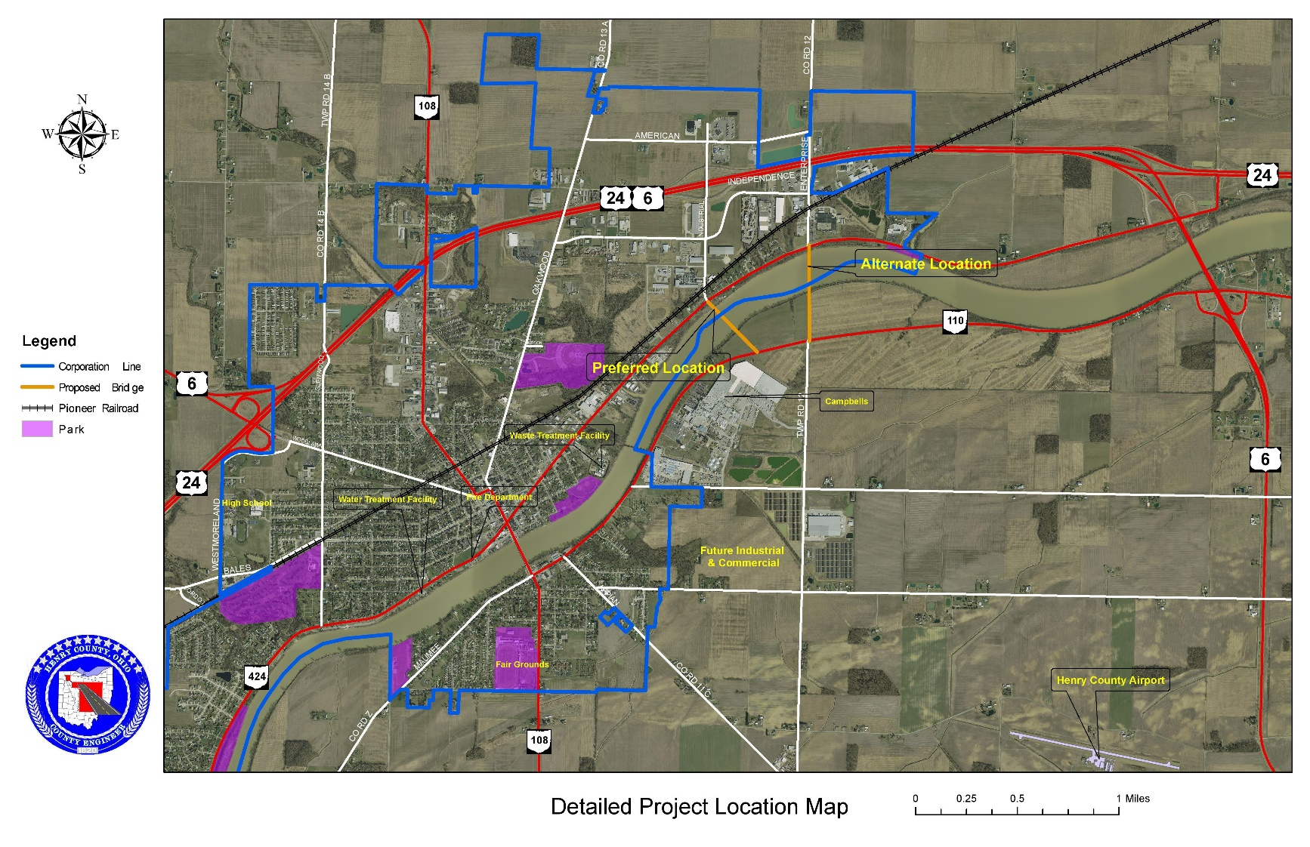
The following images show the layout of the proposed project along with various project components.
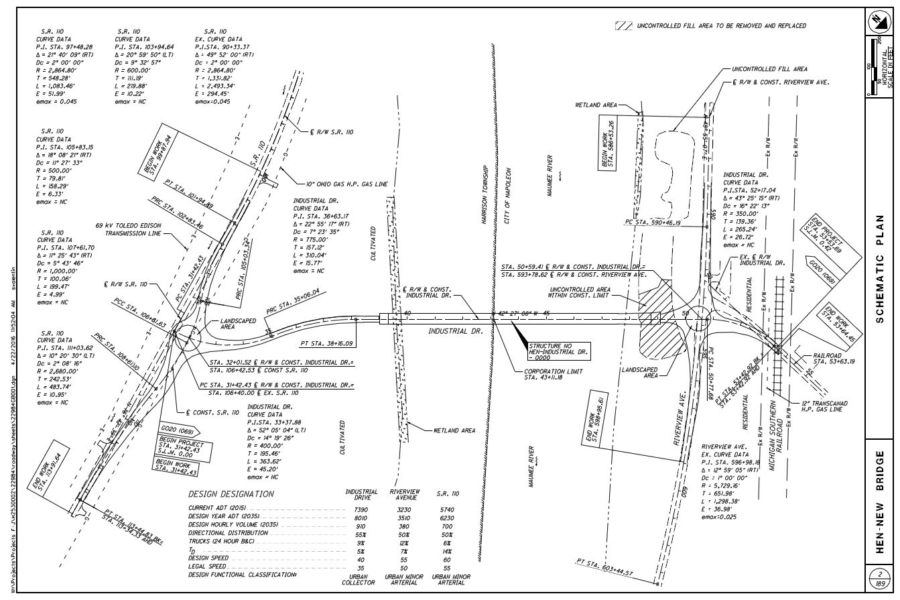

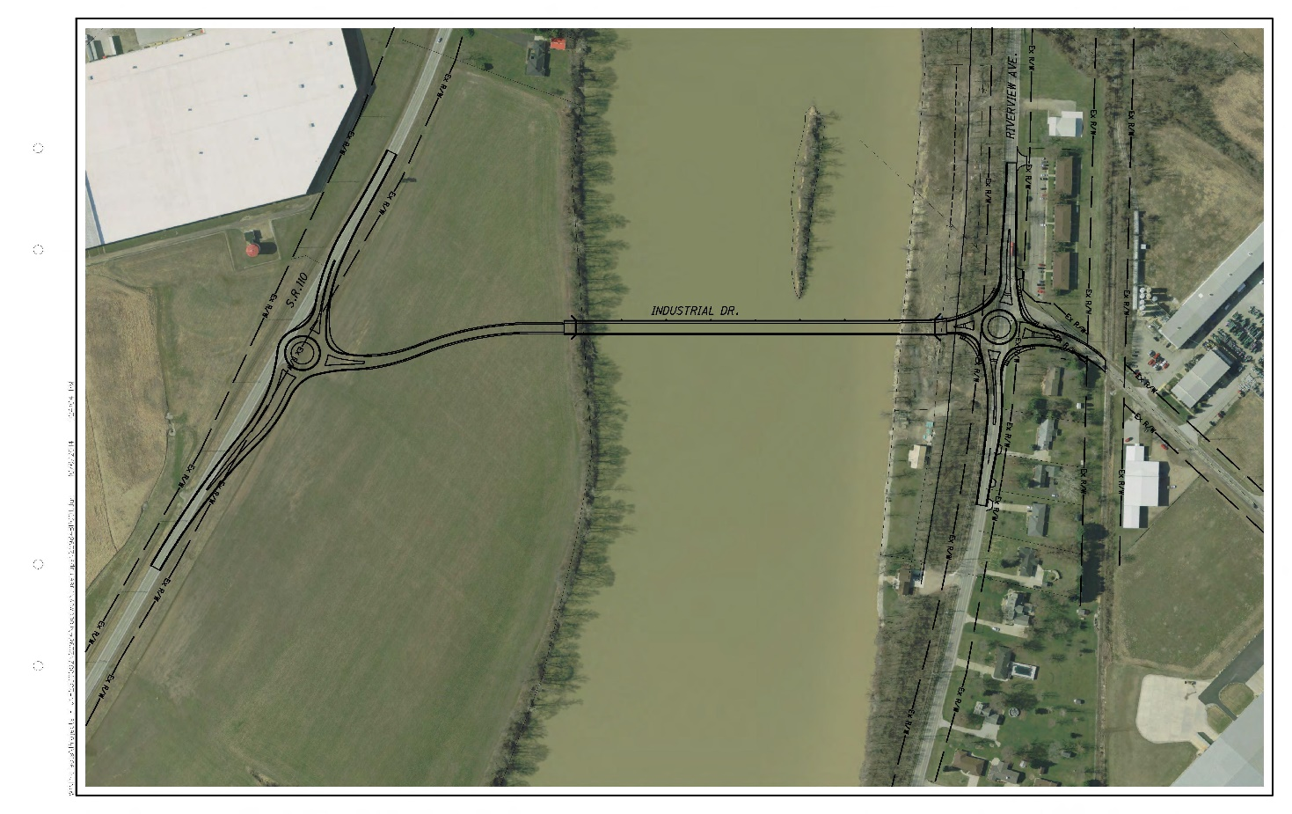

C.4 FEASIBILITY STUDY
A feasibility study for the project was completed in October 2013 by the Mannik and Smith Group, Inc. The study is included as an attachment with this application.

C.5 PROPOSED METHOD OF CONSTRUCTION
The proposed project will be constructed using the traditional design, bid, and build with sealed competitive bids.

C.6 CONSTRUCTION CONTRACTS
There will only be one construction contract for this project. However, other contracts may be needed for other project elements such as inspection and testing services, mussel relocation, etc.
C.7 DETAILED COST ESTIMATE
The detailed cost estimate for the proposed project is included as an attachment with this application.

C.8 REAL PROPERTY ACQUISITION
The project cost does not include any costs for real property acquisition.
C.9 LIST OF PERMITS
  - Table 2: List of Permits
Permit | Submittal Status | Approval Date | Review Agency | Comments/Notes
Permit Determination Request (for Bridge) | Approved | 02-05-2016 | Ohio Department of Transportation Office of Environmental Services | PDR approval received from ODOT-OES on 02-05-2016.
Army Corps of Engineers Section 404 Nationwide Permit (NWP)  and Section 10 Coordination for Bridge | Work has been initiated  (on-going through PDP) | Final approval  not required for CE | Ohio Department of Transportation Office of Environmental Services | Preparation of permit applications have been initiated. Permit finalization is not required for CE clearance.  On hold until the sign -offs occur on the Section 106 items.
Coordination with U.S. Coast Guard (USCG) | Complete | Final approval  not required for CE | U.S. Coast Guard/Ohio Department of Transportation Office of Environmental Services | Coordination with USCG has been completed by ODOT‐OES. Permit finalization is not required for CE clearance.  A Section 9 Permit will not be required.
Floodplains Coordination | Approved | 05-07-2015 | Local Floodplain Coordinator | Floodplain Permit signed/approved by Henry County Planning Commission Flood Plain coordinator on 05‐07‐2015.
Ohio EPA Section 401 Water Quality Certification (for Bridge) | Work has been initiated  (on-going through PDP) | Final approval  not required for CE | Ohio Department of Transportation Office of Environmental Services | Preparation of permit application has been initiated. Permit finalization is not required for CE clearance.  Submittal On Hold until the USACE Section 404 Permit is received.
NPDES Construction General Permit for Stormwater (NOI) | Coordination is on-going through the  project development process | Final approval  not required for CE | Ohio Department of Transportation Office of Environmental Services | Continued development & coordination to obtain permit is being started now. Will be finalized in next phase of project development.  Finalization is not needed for CE clearance.
Mussel Survey | Does not have to be completed for  submittal of CE document | Final approval  not required for CE | Ohio Department of Transportation Office of Environmental Services | The mussel survey and relocation will take place in the next phase of the project nearer to construction of project.  Finalization is not needed for CE clearance.

For construction of the proposed project, entry will be required onto the Napoleon, Defiance and Western Railway (Pioneer Railcorp) right-of-way. Therefore, a right of entry permit will need to be obtained. This process will take approximately 30 days to complete.

C.10 Overall Estimated Project Schedule

  - Table 3: Overall Estimated Project Schedule
Schedule Item | Status | Number of Months to Complete
Design Period | Stage 3 Design Plans have been completed and have been sent to the Ohio Department of Transportation for approval | 3 months
Obtaining of required permits | In progress | 12 months
Obtaining of required easements or rights-of-way | Final Right of Way Plans have been submitted to ODOT and approved as of 9/12/16 | 6 months
Solicitation of bids and awarding of contracts | Not yet begun | 9/1/17-12/1/17
Construction Period | Not yet begun | 4/1/18-9/30/19

C.11 OVERALL PROJECT BUDGET BREAKDOWN

  - Table 4: Overall Project Budget Breakdown
Cost Classification | Tasks | Total Cost
Land structures, right-of-way, appraisals, etc. | Environmental mitigation | $500,000.00
Relocation expenses and payments | Mussel relocation | $250,000.00
Project inspection fees | Construction materials testing and inspection | $1,200,000.00
Construction | Roadway | $824,438.59
 | Erosion control | $213,344.69
 | Drainage | $267,470.70
 | Pavement | $1,136,111.44
 | Lighting | $96,913.67
 | Traffic control | $30,009.90
 | Landscaping | $11,419.49
 | Structure 20 foot span and over | $7,121,724.14
 | Maintenance of traffic | $76,850.05
 | Incidentals | $554,532.19
 | Contingency (12.68%) | $1,310,408.00
 | TOTAL | $13,593,223

This report was prepared under my direction and supervision.

Patrick M. McColley, P.E., S.I.
Ohio P.E. Number: 76703
Chief Deputy County Engineer
Henry County Engineer’s Office
1823 Oakwood Avenue
Napoleon, OH 43545
Phone: 419-592-2976
Fax: 419-592-5508
Email: pmccolley@henrycountyengineer.com.

